Module Development in DNN 8: 1 – Introduction to MVC modules
A new CTP for DNN 8 was released today. This CTP contains updated support for building modules using the ASP.NET MVC Framework as well as new support for building HTML 5 based modules. This adds to the existing support for building modules with ASP.NET WebForms (User Controls) and Razor scripts.
With this extended support DNN 8 becomes the only .NET CMS that offers module developers a choice of all the available ways to build extensions.
In this new blog series I will describe these new features while building a module to manage Contacts. This post is an introduction to developing MVC based modules.
A bit about routing
The first thing to note is that the approach we have taken is to embed the MVC application inside an ASP.NET Web Forms server control. This is a similar approach to how we provided Razor support a few years ago, and is also the same approach we are using to support Single Page Application style modules using HTML 5, JavaScript and CSS.
This doesn’t really affect how module developers code their MVC modules, except that it means that routing is done a little differently. As an MVC module developer you don’t need to define any routes as DNN handles the routing (or URL Rewriting). We will however still support Html and Url helpers that defined links using action names and controller names. However, we will create urls that work within the DNN Url handling system.
Setting up your environment
In this introductory blog I will show how to set up Visual Studio (2015) to develop our first DNN MVC module. As a pre-requisite you will need to install the CTP which you can get from codeplex. Alternatively you can get the latest code by cloning the feature/8.0.0 branch of the DNN.Platform Github repository (https://github.com/dnnsoftware/Dnn.Platform).
Open Visual Studio (in my case I am using Visual Studio 2015 RC) and create a solution for you MVC module. Once you have created your solution, add a Web Application Project – select the Empty template (1) but check MVC (2) so that the MVC references are added to the empty project.
Figure 1 - Creating an MVC Project
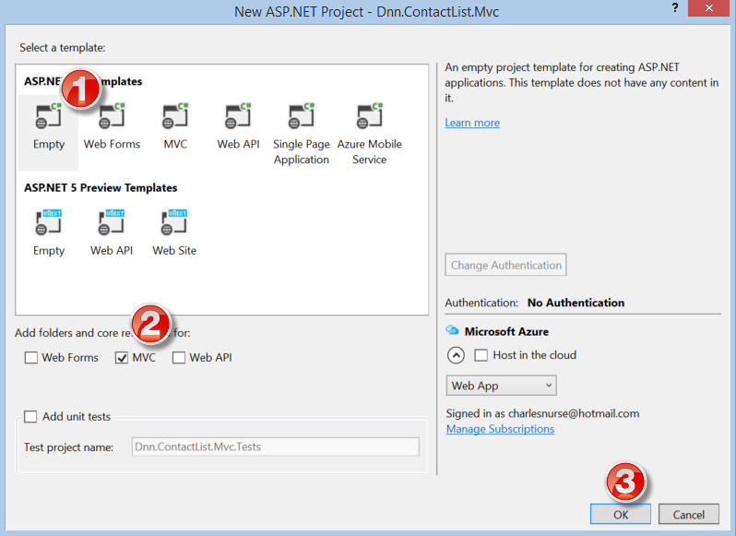
Remove the files and folders added by the template – except the Controllers, Models and Views folders – and add an App_LocalResources folder (for our localization resources). You should have something that looks like Figure 2.
Figure 2 – Empty MVC Project
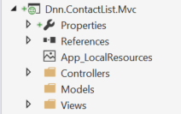
I like setting up my projects so that I can deploy them to my site as well as package them for installation so in order to do that we need to add some extra files to the project.
The Module.build File
The first file to add is an MS Build file. This MS Build file is shown in Figure 3 (don’t worry if you can’t read everything in the file – as noted above the source for this project is available on Github (https://github.com/cnurse/DnnConnect.Demo), so you can copy the file on Github for use in your project.
Figure 3 – The Module.build File
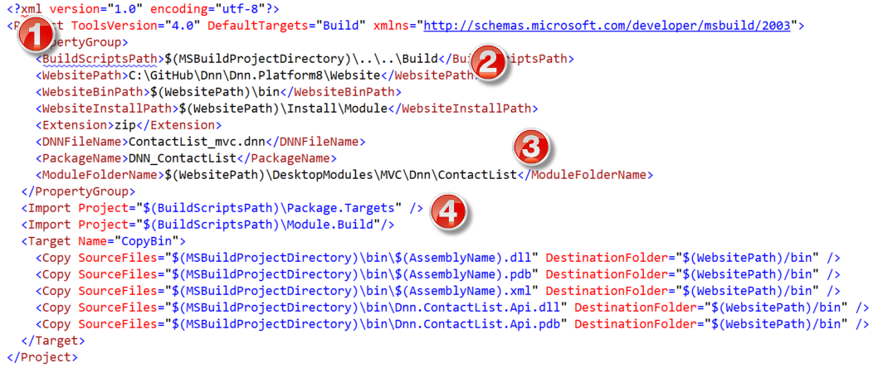
There are four important properties in this file some of which will need to be modified for your installation:
- The BuildScriptsPath points to the folder where supporting build scripts are stored.
- The WebsitePath must point to the root of your DNN 8.0 website
- The ModuleFolderName points to where your module will be deployed within the website – your module should be under the MVC folder within DesktopModules. This is important as this will mean that the web.config file that lives in that folder will apply to your MVC module. This web.config file allows the Razor Views to work just as they would in a stand-alone MVC Application with the change that the base WebViewPage is a DnnWebViewPage.
- The two Imports statements points to two MS Build files that are used to deply and/or package the module. These files are copies of the files shipped with the DNN source and are located in the BuildScriptsPath folder.
To enable the build file to work you need to modify the module’s project file. To do that, “Unload” the project and Edit the project as an XML file, and insert the Import element highlighted in Figure 4 at the bottom of the file.
Figure 4 – Adding the Import Statement to the Project File
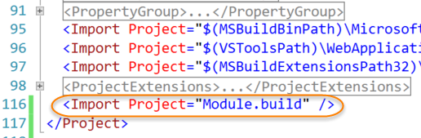
The DNN Manifest file
Next we will need to add a DNN manifest file. Figure 5 shows the DNN manifest file I have created for the ContactList project.
Figure 5 – The DNN Manifest file
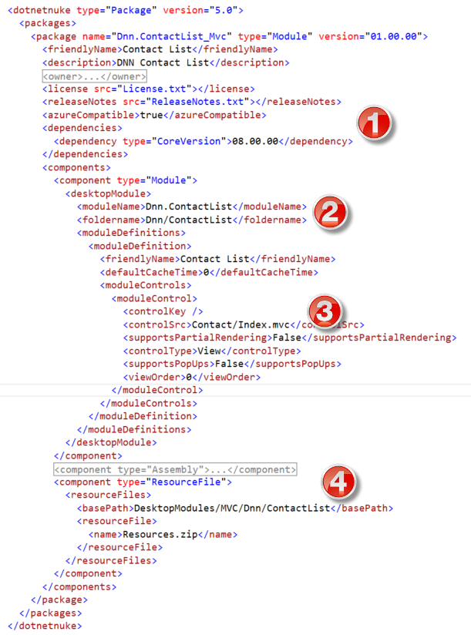
Note the following 4 points about this file:
- There is a dependency node as MVC modules require a core DNN version of 8.0.0 or later
- The folderName property supports two levels just like legacy module types (for this property the MVC folder is implied)
- The controlSrc property uses the “fake” extension “.mvc” to identify that this control is an MVC control. I will go into more detail about this in a future post.
- The ResourceFile component and any File component needs to include the MVC folder in the basePath.
Most of the other files in the root of the project are self-explanatory. In the next post in this series I will show how to build your first MVC View.

Module Development in DNN 8: 2 - Creating your first MVC Action/View
In my previous blog I reviewed the development environment I will be using for my blog series on Module Development in DNN 8. As a reminder you can find all the sample code on Github at https://github.com/cnurse/DnnConnect.Demo. In this blog we will create our first MVC Action and View.
The Model
As mentioned in my previous blog I will be describing how to create a module to manage contacts on my site. The Contact List module will be scoped to the portal – i.e. all contacts for a portal will be available in any instance of the module. A Contact will have 5 simple properties:
- First Name
- Last Name
- Email Address
- Phone Number
- Twitter Handle
As the domain is not what we are really focusing on in this series I have kept it simple. As we will be creating both an MVC module (as well as a SPA module in future blog posts) I have created a separate project for the Model (API) located in the Dnn.ContactList.Api project (Figure 1).
Figure 1 – The Model project
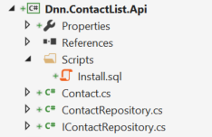
The Api uses the DAL 2 data access layer and implements a simple “Repository” facade over that framework. As with many of DNN's APIs the ContactRepository is implemented using the ServiceLocator pattern so the methods can be Unit Tested.
The IContactRepository interface provides a simple CRUD API, as shown in Figure 2.
Figure 2 – The IContactRepository interface
1: public interface IContactRepository
2: {
3: int AddContact(Contact contact);
4:
5: void DeleteContact(Contact contact);
6:
7: Contact GetContact(int contactId, int portalId);
8:
9: IQueryable<Contact> GetContacts(int portalId);
10:
11: IPagedList<Contact> GetContacts(string searchTerm, int portalId, int pageIndex, int pageSize);
12:
13: void UpdateContact(Contact contact);
14: }
The MVC Controller
So now we have everything set up we are ready to create our first MVC Action and View. Following the MVC convention we will create a class in the Controllers folder called ContactController. This class must inherit from the DnnController base class found in the DotNetNuke.Web.Mvc project. This base class inherits from the core MVC Controller base class, but adds extra support for the DNN Module and Portal context. You can think of this class as the equivalent to PortalModuleBase in WebForms module development.
Figure 3 – The ContactController class
1: public class ContactController : DnnController
2: {
3: private readonly IContactRepository _repository;
4:
5: public ContactController() : this(ContactRepository.Instance) { }
6:
7: public ContactController(IContactRepository repository)
8: {
9: Requires.NotNull(repository);
10:
11: _repository = repository;
12: }
13: }
This class has two constructors. The parameter-less constructor is used by the MVC framework to instantiate the controller, and the second constructor will be used by our Unit Tests. Use of either constructor will set the private IContactRepository variable.
In the future (DNN NeXt) we will be able to dispense with the parameter-less constructor and allow ASP.NET 5’s Dependency Resolver to inject the appropriate implementation of the interface. I have used this approach rather than calling DotNetNuke.Instance.<<Method>> in each action method as this will be the pattern used in DNN NeXt.
The Index Action
Next we need to add an action method – the default method is usually called Index by convention. As we are not really using ASP.NET routing the name is not that important, as DNN actually determines the controller and action to call from the “ControlSrc” property of the Module Control (Contact/Index.mvc).
The Index action is listed in Figure 4.
Figure 4 – The Index Action
1: [HttpGet]
2: public ActionResult Index()
3: {
4: var contacts = _repository.GetContacts(PortalSettings.PortalId);
5:
6: return View(contacts.ToList());
7: }
This is a fairly simple MVC Action method. In the first line we use the HttpGet attribute to indicate that this method should only be called by HTTP “GET” calls. In line 2 we return an ActionResult – the DNN MVC framework captures this result and renders it in the MvcHostControl. In line 4 we call the GetContacts method of the repository interface to get all the contacts for the portal. Note, that just like PortalModuleBase the DnnController base class provides access to the PortalSettings object. Finally in line 6 we return a strongly typed View, passing in our List of contacts.
The Index View
We now turn our attention to the View. DNN supports all the MVC 5.1 conventions for Views. Thus, you can provide a _ViewStart.cshtml razor script which will execute for all Views before any other View code, and it supports the use of layout views. Figure 5 shows this layout.
Figure 5 – MVC View Conventions
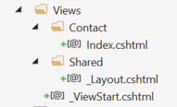
Lets look at each of these Razor files.
Figure 6 – _ViewStart.cshtml
1: @{
2: Layout = "~/DesktopModules/MVC/Dnn/ContactList/Views/Shared/_Layout.cshtml";
3: }
The _ViewStart.cshtml file is used to set the Layout property for all the Views. This allows the module developer to use some common “chrome” for all the Views in the module.
Figure 7 – _Layout.cshtml
1: <div class="masterLayout">
2: @RenderBody()
3: </div>
For this module the shared layout is very simple (being just a wrapper to the required RenderBody() method), but this could be used to register extra css or JavaScript files.
The main view code (Index.cshtml) is shown in Figure 8.
Figure 8 – Index.cshtml
1: @inherits DotNetNuke.Web.Mvc.Framework.DnnWebViewPage<IList<Dnn.ContactList.Api.Contact>>
2:
3: <div>
4: @foreach (var contact in Model)
5: {
6: <div class="contactCard">
7: <div>
8: <span>@contact.FirstName</span>
9: <span>@contact.LastName</span>
10: </div>
11: <div>
12: <span>Email:</span>
13: <span>@contact.Email</span>
14: </div>
15: <div>
16: <span>Phone:</span>
17: <span>@contact.Phone</span>
18: </div>
19: <div>
20: <span>Twitter:</span>
21: <span>@contact.Twitter</span>
22: </div>
23: </div>
24: }
25: </div>
The first thing to note is Line 1. DNN Views need to inherit from the DnnWebViewPage class. This is because we need to modify some of the helper methods, as well as provide support for DNN context (ModuleContext and PortalSettings). The rest of the code is fairly straightforward Razor script. We loop over all the contacts in the Model property (which is a List of Contact objects), and render the properties of the contact. With some simple styling we can see the View output in Figure 9.
Figure 9 – The View output
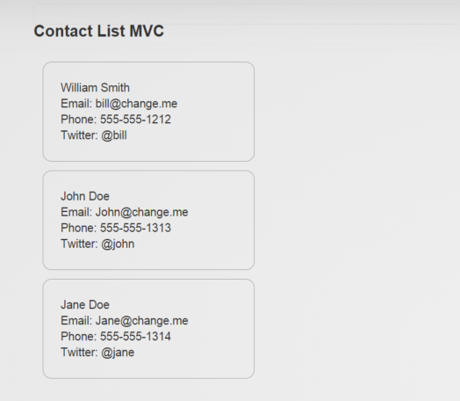
So thats our first MVC Action/View. In my next blog post (on MVC modules) I will show how we can add support for other Actions/Views.

Module Development in DNN 8: 3 - Introduction to SPA modules
In addition to ASP.NET MVC modules, DNN 8 will support SPA (Single Page Application) modules, developed purely with HTML JavaScript and Css, together with ASP.NET Web API based Web Services on the Web Server. DNN currently supports this module type – to a degree - but the HTML is required to be in the WebForms User Control. A number of the newer modules have been built this way, for example the Core Messaging module and Membership modules found in the User Profile are built in this way.
In DNN 8 the requirement to use User Controls or a Razor script is removed. Module Controls can be pure HTML files with the extension .html or .htm, and the Module injection framework will load the html into an HtmlHostControl in a similar way to how MVC modules are handled.
Setting up your Environment
We still need to create a Visual Studio project to hold our Web API classes, so the environment setup is similar to what we used for MVC modules. In my project which is available on Github I have both modules in the same solution, so add a new Web ApplicationProject to your solution called Dnn.ContactList.Spa, choose the Empty template (1) and select Web API (2) so that the Web API references are added to your project.
Figure 1 – Creating a Web API project
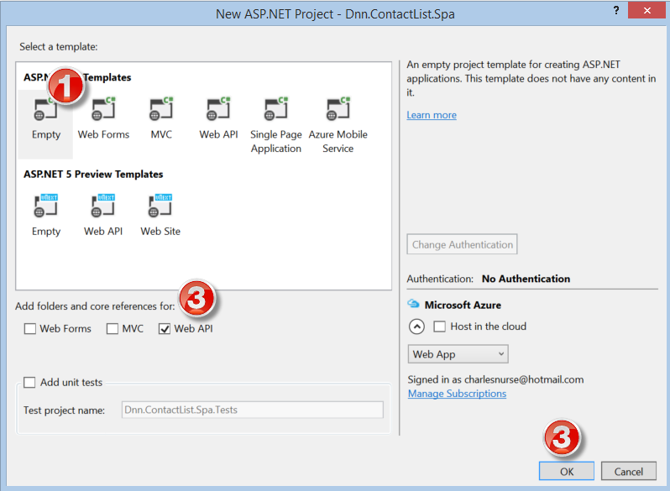
As before we will be adding the same default files including a module.css file, a module.build file and a DNN manifest file. In addition we will need an HTML file (ContactList.html) and a JavaScript file (ContactList.js).
After adding these files and removing the unnecessary files and folders created by the template you should have something like Figure 2.
Figure 2 – The Dnn.ContactList.Spa project
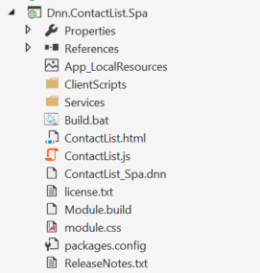
There is not much to comment on in this setup. SPA modules controls The manifest looks like any normal manifest except the controlSrc property has a .html extension. As with MVC modules the manifest should include a dependency node to indicate that the CoreVersion should be 8.0.0 or higher (see Figure 3)
Figure 3 – Sections of the Manifest file of note
<dependencies>
<dependency type="CoreVersion">08.00.00</dependency>
</dependencies>

<moduleControl>
<controlSrc>DesktopModules/Dnn/ContactList/ContactList.html</controlSrc>
<supportsPartialRendering>False</supportsPartialRendering>
<controlType>View</controlType>
<supportsPopUps>False</supportsPopUps>
<viewOrder>0</viewOrder>
</moduleControl>
The main addition in this setup is the inclusion of the JavaScript file (ContactList.js). This file is not required – the JavaScript can live in a different file or even in the HTML file itself, but by convention a JavaScript file with the same root name as the HTML file is automatically registered (if present)and the link added to the top of the form. Other JavaScript files can also be registered, which will be discussed in a future post.
That's it for our SPA module development environment. In the next blog post I will show how to display a list of Contacts in a SPA module.

Module Development in DNN 8: 4 - Localization support for MVC modules
DNN 8 will support creating modules using ASP.NET MVC version 5.1 or later. In previous blogs in this series I showed how you can set up your environment to create MVC modules and I created my first MVC Action/View. In this blog I will describe the support we have included for localizing text in MVC Controllers and MVC Views. As before the source code for my examples is available on Github at https://github.com/cnurse/DnnConnect.Demo.
MVC Controllers
In my earlier blog I described how DNN provides a base Controller (DnnController) that developers can sub-class, when building modules using ASP.NET MVC. This base class provides Portal and Module context as well as some helper methods – just like PortalModuleBase does for “classic” WebForms based DNN modules.
Localization is provided by two members of the base class – a LocalizeString method and a LocalResourceFile property.
Listing 1: Localization support in DnnController base class
1: public string LocalResourceFile { get; set; }
2:
3: public string LocalizeString(string key)
4: {
5: return Localization.GetString(key, LocalResourceFile);
6: }
The LocalizeString method is similar to the LocalizeString method in PortalModuleBase. It calls the Localization class passing the key and the LocalResourceFile. The LocalResourceFile name can be anything you want, but by convention it defaults to <<Controller>>.resx. In the case of the example project which has a single controller – ContactController, the default LocalResourceFile value is Contact.resx.
There isn’t an example of the use of LocalizeString in the example project – you are most likely to need localized strings in the UI, so there is also support for localization in your MVC Views.
Dnn View Helper
As mentioned in the earlier blog DNN also provides a default base View – DnnWebViewPage. As long as you make your views inherit from this base WebViewPage (or its generic equivalent DnnWebViewPage<TModel>) then you will have access to a Dnn helper class.
The Dnn helper class also supports the same two members – so you can use the helper syntax @Dnn.LocalizeString(key) in your Razor views. As before you can set the LocalResourceFile property or use the default convention which is the same as before, i.e. the <<Controller>>.resx, where <<Controller>> is the parent Controller class for the view.
The sample code includes the use of this method in both of its views (see Listing 2)
Listing 2: Use of the Dnn Localization helper
1: <div>
2: <span>@contact.FirstName</span>
3: <span>@contact.LastName</span>
4: </div>
5: <div>
6: <span>@Dnn.LocalizeString("Email")</span>
7: <span>@contact.Email</span>
8: </div>
9: <div>
10: <span>@Dnn.LocalizeString("Phone")</span>
11: <span>@contact.Phone</span>
12: </div>
13: <div>
14: <span>@Dnn.LocalizeString("Twitter")</span>
15: <span>@contact.Twitter</span>
16: </div>
That’s it – we have tried to keep the experience familiar to DNN developers while embracing MVC standards. Please give it a try and tell us what you think.

Module Development in DNN 8: 5 - New tokens to support building pure SPA modules
DNN 8 will support creating modules using a SPA (Single Page Application) model using HTML 5, JavaScript and ASP.NET Web API based web services. In a previous blog in this series I showed how you can set up your environment to create SPA modules. This model development style has been available ever since we added support for ASP.NET Web API, but in DNN 8 we have added support for html files to be module controls. This means that we no longer require some form of code-behind file. So how do we do things like registering JavaScript files that we used to do in those code behind files. In this blog I describe how we have extended DNNs token support to provide these abilities. As before the source code for my examples is available on Github at https://github.com/cnurse/DnnConnect.Demo.
Registering JavaScript and Css files
We already have examples in DNN of using HTML, JavaScript (AJAX) and ASP.NET Web API for developing modules. So in this blog I will focus on the new tokens that can be used to accomplish most of the tasks that used to be done in the code behind files. In our existing examples (the Member Directory and Messaging modules used in the DNN User Profile) we register JavaScript and css files by using a server-side control (DnnJsInclude or DNNCssInclude) or by making a call to the Client Resource Framework. Neither of these approaches is possible with a purely HTML control.
In order to register JavaScript and css file we have added two new tokens. These tokens are slightly different from the existing Tokens. Traditional DNN Tokens have the format [Entity : Property] and return a string, i.e. the token is replaced by the value of the property.
These new Tokens do not return anything – instead some action take place – in this case the JavaScript or CSS files are registered with the Client Resource Framework. Another feature of these tokens is that the syntax is a little different as the right hand side (the “property”) is expressed as JSON. This allows us to define a standard approach for all of these extended tokens.
Listing 1: Use of the JavaScript token
[JavaScript:{ jsname: "Knockout" }]
[JavaScript:{ path: "~/DesktopModules/Dnn/ContactList/ClientScripts/contacts.js"}]
[JavaScript:{ path: "~/DesktopModules/Dnn/ContactList/ClientScripts/util.js"}]
[JavaScript:{ path: "~/Resources/Shared/scripts/dnn.jquery.js"}]
Listing 1 shows the use of the JavaScript token in the example code. If a JavaScript Library has been defined (such as jQuery or Knockout) you can use the first form. The first form supports the following parameters:
- jsname – the name of the default library
- version – the version to use
- specific – a setting which controls how the framework chooses the version to render – this has 4 values
  - Exact – the exact version
  - LatestMajor – the latest major version
  - LatestMinor – the latest minor version
  - Latest – the latest version registered.
The second form is used for JavaScript files that have not been registered as JavaScript libraries. This form supports the following parameters:
- path – the path to the location of the file
- priority – the priority to use when rendering the link – files with lower priority are rendered first
- provider – the provider to use
Note: that the token name “js” can also be used as an alias to the JavaScript token.
The example code on Github does not include an example of the Css token as the example code only includes the standard DNN module.css file but the parameters for the Css token are exactly the same as the second form of the JavaScript token. Listing 2 shows the statements used in the new Dynamic Content Type Manager which will be included in CTP 3 of DNN 8, which registers a css file for codemirror as well as the Font-Awesome icon library. Note that remote paths, such as a CDN can be used.
Listing 2: Use of the Css token
[Css:{ path: "//maxcdn.bootstrapcdn.com/font-awesome/4.3.0/css/font-awesome.min.css"}]
[Css:{ path: "~/Resources/Shared/components/CodeEditor/lib/codemirror.css"}]
An additional feature of these tokens is that they can also be used in the DNN HTML module to register JavaScript or Css.
Resx Localization Token
We have also added a token to allow Localization values to be rendered into the HTML. This is more like a traditional Token Replace token in that this token when parsed is replaced by a value – the result of the localization.
Listing 3: Use of the Resx Localization token
1: <div class="contactCard">
2: <div class="right">
3: <a title="[Resx:{key:'Edit'}]" data-bind="click: $parent.editContact">
4: <i class="fa fa-pencil"></i>
5: </a>
6: <a title="[Resx:{key:'Delete'}]" data-bind="click: deleteContact">
7: <i class="fa fa-trash"></i>
8: </a>
9: </div>
10: <div>
11: <span data-bind="text: firstName"></span>
12: <span data-bind="text: lastName"></span>
13: </div>
14: <div>
15: <span>[Resx:{key:"Email"}]</span>
16: <span data-bind="text: email"></span>
17: </div>
18: <div>
19: <span>[Resx:{key:"Phone"}]</span>
20: <span data-bind="text: phone"></span>
21: </div>
22: <div>
23: <span>[Resx:{key:"Twitter"}]</span>
24: <span data-bind="text: twitter"></span>
25: </div>
26: </div>
This token also uses the JSON format. It supports two parameters:
- key – the resource key
- localresourcefile – the local resource file
If the localresourcefile parameter is not included then the file defaults to <<HTMLFileRoot >>.resx where HTMLFileRoot is the filename (without extension) of the current HTML file. i.e. if the html file is ContactList.html the relevant resx file is ContactList.resx.
Note that because the html is parsed on the server before being rendered to the browser the token can be used inside an attribute, and the “localized value” is found in the HTML sent to the browser.
ModuleContext Token
In DNN8 CTP 2 there is an additional token (which is still under development) – the ModuleContext token. This token is designed to provide some support for passing some module context to the client. In reality the only ModuleContext that is required is the module Id, as a JavaScript developer could write a Web API service that uses the moduleId to get more detailed context. But this requires an extra request, so we are still considering what we need to provide as a minimal set of properties for this token.
CTP 2 supports two properties for the ModuleContext token:
- moduleId – the Id of the module
- issuperuser – a Boolean that indicates whether the current user is a Super (Host) User
That's it for new tokens. Have fun developing new SP modules – let us know what you think.

Module Development in DNN 8: 6 - Handling Module Actions in MVC and SPA modules
DNN 8 will support creating modules using ASP.NET MVC version 5.1 (or later) as well as using a SPA (Single Page Application) module using HTML 5, JavaScript and ASP.NET Web API. In previous blogs in this series I have described how these modules can be built and I have shown how localization is handled. One topic still to describe is how both of these approaches can register module actions so they show on DNN’s module action menu.
ModuleAction attribute
I will start with how Module Actions can be registered for MVC modules. In a Web Form’s code-behind file you can add Module Actions by implementing the IActionable interface. This approach is not possible in an MVC Controller as the Controller can have many “Views” and each View would need its own set of Module Actions. We therefore decided to add a new ModuleAction attribute implemented as an MVC Action Filter. This attribute allows you to define a Module Action.
Listing 1: The ModuleAction Attribute
1: [HttpGet]
2: [ModuleAction(ControlKey = "Edit", TitleKey = "AddContact")]
3: public ActionResult Index()
4: {
5: var contacts = _repository.GetContacts(PortalSettings.PortalId);
6:
7: return View(contacts.ToList());
8: }
Each ModuleAction attribute will add a single Module Action to the Module Actions menu. In this case, the Module Action is the “Edit” action and its title is defined by the Localization key “AddContact”. The ModuleAction attribute exposes the following properties:
- ControlKey – the key used to identify the Module Control to load
- Icon – the Url for the Icon to use
- SecurityAccessLevel – the SecurityAccessLevel setting
- Title – the title (text) displayed in the Actions menu
- TitleKey – the localization key for the Title (if present this overrides the Title setting)
Each ModuleAction attribute defines a single Module Action. For complex modules this could mean that an Action method could have a lot of ModuleAction attributes. In addition the attribute only defines a subset of the ModuleAction properties – it is designed to provide a simple solution to cover the 80% use case. To cover more complex situations we have also included a ModuleActionItems attribute.
ModuleActionItems attribute
The ModuleActionItems attribute is also implemented as an Action Filter. It has two parameters:
- Type – the type of a class (if not present this will default to the current Controller)
- MethodName – the name of a method to call in the class defined by the Type parameter. If not present this defaults to “Get{ActionMethos}Actions” where {ActionMethod} is the name of the Action Method where the attribute is applied.
As an example lets replace the single ModuleAction attribute in Listing 1 with the ModuleActionItems attribute. The code changes are shown in Listing 2.
Listing 2: The ModuleActionItems attribute
1: [ModuleActionItems]
2: public ActionResult Index()
3: {
4: var contacts = _repository.GetContacts(PortalSettings.PortalId);
5:
6: return View(contacts.ToList());
7: }
8:
9: private ModuleActionCollection GetIndexActions()
10: {
11: var actions = new ModuleActionCollection();
12:
13: actions.Add(new ModuleAction(-1)
14: {
15: CommandName = ModuleActionType.AddContent,
16: CommandArgument = String.Empty,
17: Icon = String.Empty,
18: Title = LocalizeString("AddContact"),
19: Url = ModuleContext.EditUrl("Edit"),
20: Secure = SecurityAccessLevel.Edit,
21: UseActionEvent = false,
22: Visible = true,
23: NewWindow = false
24: });
25:
26: return actions;
27: }
Essentially the ModuelActions attribute works just like IActionable, returning a collection of module actions.
Module Actions in SPA modules
One of the tenets of SPA modules is that they are built using a Single Page Application style. This essentially means that the module shouldn’t need any Module Actions to load a secondary “page”. However for completeness we have added a ModuleAction token. The ModuleAction Token works like the other JSON based tokens I described in my previous blog, and works like the ModuleAction attribute exposing the same set of parameters.
- controlKey
- icon
- securityAccessLevel
- title
- titleKey
It also adds an extra parameter so you can identify the “localResourceFile” to use for the titleKey field. For example the token for the Edit ModuleAction used above would be:
[ModuleAction : {controlKey: “Edit”, securityAccessLevel : “Edit”, titleKey: ”AddContent”, localResourceFile:”~/DesktopModules/Dnn/ContactList/App_LocalResources/ContactList.resx” }]
So now you can add Module Actions to your MVC or SPA modules – have fun with this new development style and let us know what you think.

